Vehicle and modifier details
Vehicle make: | Vehicle model: | Month and year of manufacture:
VIN (if applicable): | Vehicle chassis no. (if applicable): | Vehicle modifier (company name):
For brake torque build-up checks:
You need to:
- measure braking torque and line pressure (or pedal force) unless you can produce equivalent and acceptable documentary evidence
- use a roller brake-test dynamometer to establish this relationship
- utilise the graph format below only if the specifications of the brakes on the additional axle are different to those of an adjacent axle
- consider alternative evidence if no roller brake test dynamometer is available.

Brake torque characteristics graph results
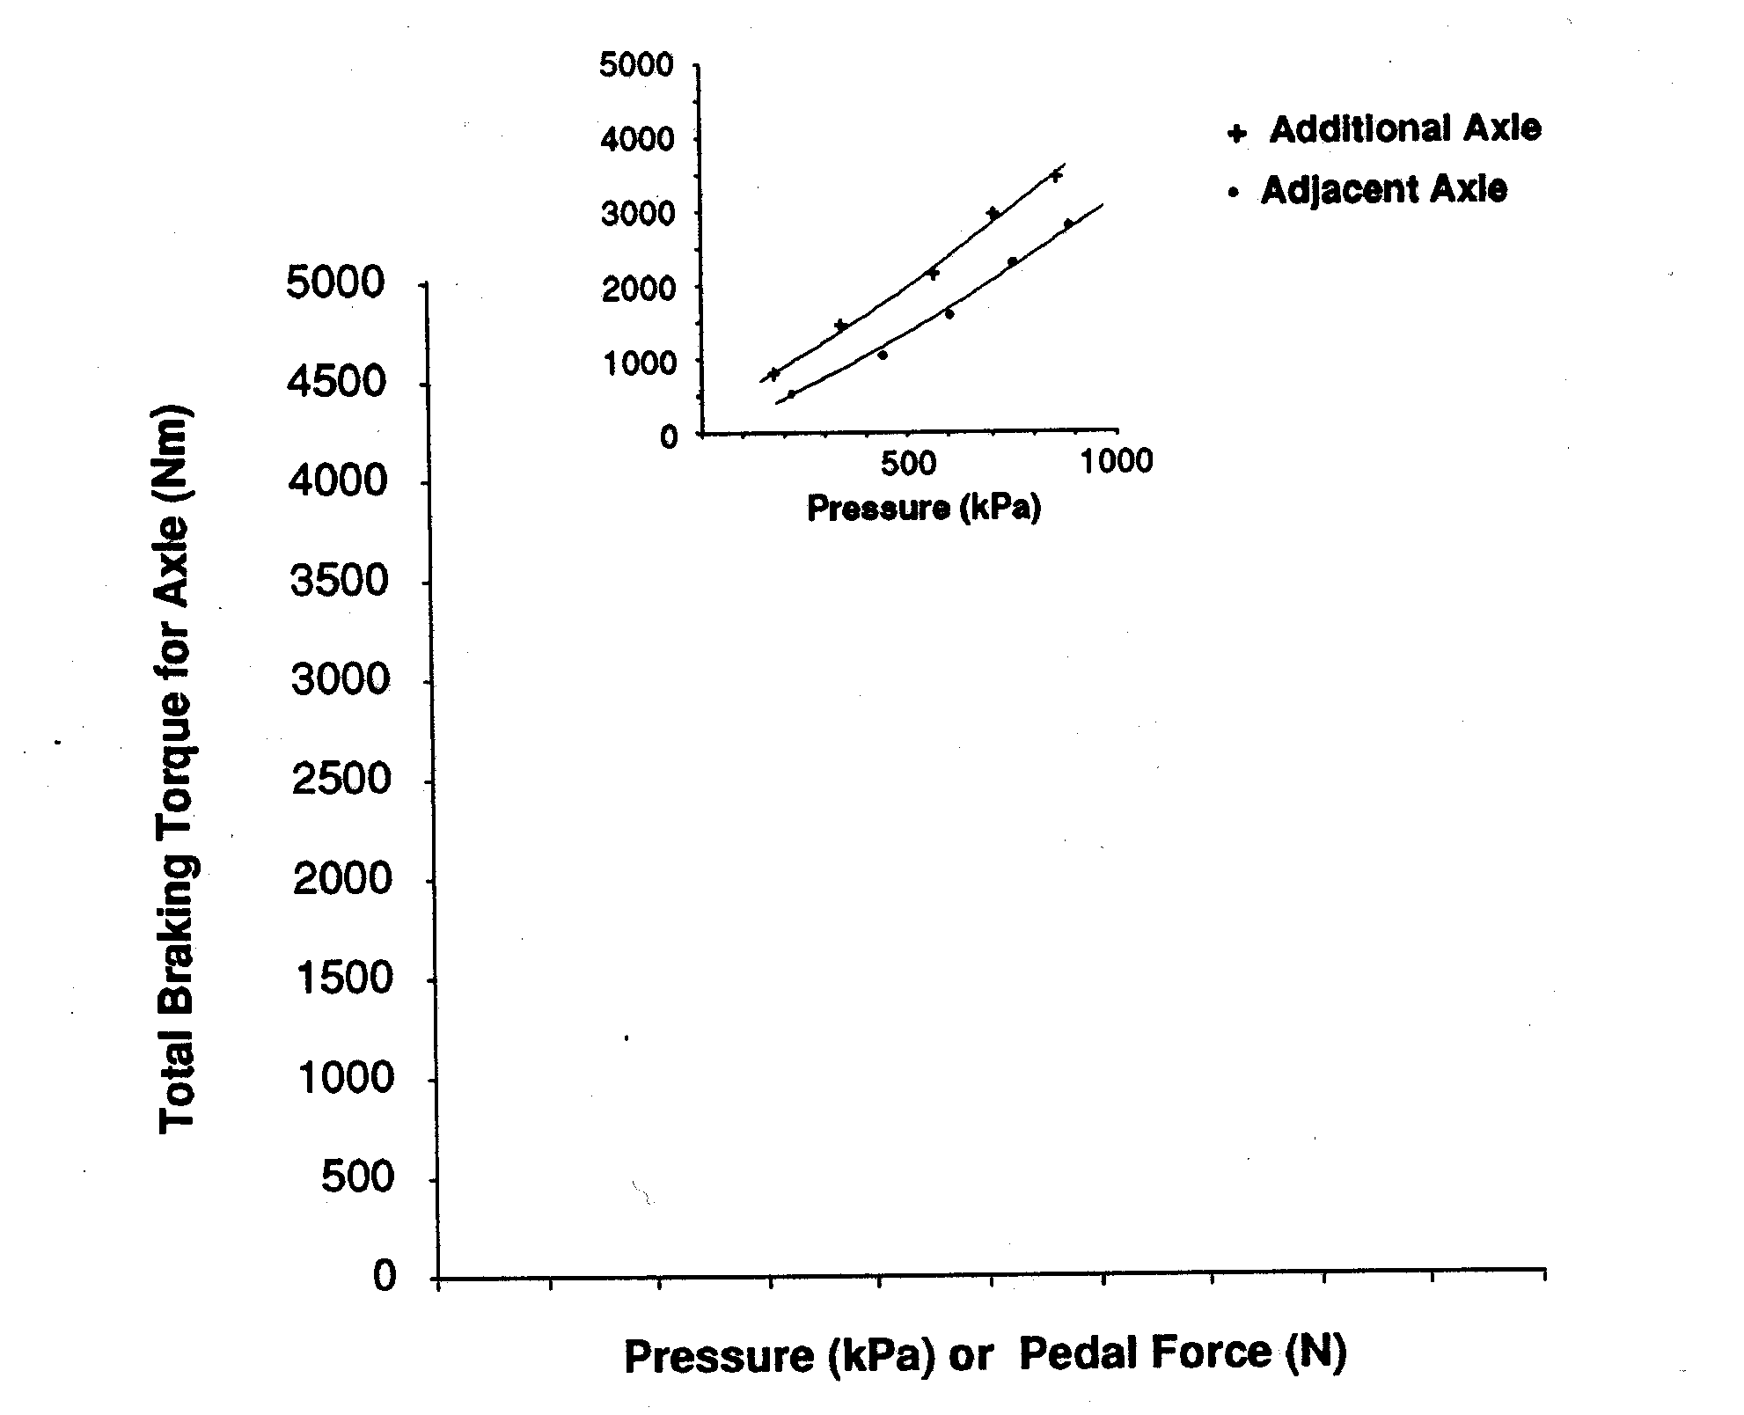

Authorisation
Other than modification criteria, if the answer to any relevant question is NO the modification is not acceptable.
Comments:
Test performed by: |  | Company (if applicable): | Signed: | Date:

