Vehicle and modifier details | Report no.:
Vehicle make: |  |  |  |  |  |  |  | Vehicle model: | Month and year of manufacture:
VIN (if applicable): |  |  |  |  |  |  |  | Vehicle chassis no. (if applicable): | Vehicle modifier (company name):
Fifth wheel make: |  |  |  |  |  |  |  | Fifth wheel model: | Fifth wheel approval no. (CNR etc.):
Base: |  |  |  |  |  |  |  | Base make and model:
Fixed | ☐ |  | Rotating | ☐ | Sliding |  | ☐
Compliant with AS/NZS4968? |  |  |  |  |  |  |  | If No, alternative standard applicable:
Yes |  | ☐ |  | No |  | ☐

Results
Installation  Wheelbase in mm WB =  Tare mass front axle kg MFT =  King pin lead mm (FOC) KPL =  Height mm H =  Imposed max. load kg MI =  Max. static load front axle kg MF =  Manufacturer front axle rating kg  Forward projection radius mm FPR =  Mountings  Mounting angle  Size in mm = min. 100 x 75 x 10 or equivalent  Length in mm = min. chassis width + 600  Mounting bolts  No. of bolts Dia. Grade  Base plate to angle:  Angle to chassis: no. of bolts  Clearance  Top of chassis to top of angle in mm  For sliding assemblies:  Describe means of positive locking  Describe slide slope and give bolt size or weld size and length | 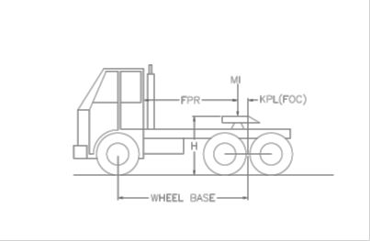  H Should be 1220 mm + 100 mm / -70 mm  MF Must not exceed the least of the legal limit tyre capacity or manufacturer’s rating  MF Should not be less than MFT  KPL Recommended minimum 2% WB  $$MF=MFT+\frac{MI X KPL}{WB}$$  KPL is measured forward of the axle group centreline (FOC). Where the articulation point is rear of centre, the KPL is negative. Whilst positive KPL is recommended, the fifth wheel position should be chosen so that it is appropriately located with respect to the rear axle group centre.

Authorisation
Comments:
Examined by: |  | Company (if applicable): |  | AVE no.:
Signed: |  | Modification certificate no.: | Modification plate no.: | Date:

