TRA No.: | Version No.: | Review due date: | Authorised by:

Task/activity

Task name
Frequency
Location
Task coordinator |  | Assessment date
* The term “task” may be replaced with hazard, chemical, activity, process, or any other subject being assessed.

 | Risk matrix |  | Consequence
 |  | Minor |  | Moderate | Major | Extreme
Likelihood | Almost certain | Moderate |  | High | Critical | Critical
Likelihood | Likely | Moderate |  | High | Critical | Critical
Likelihood | Possible | Moderate |  | Moderate | High | High
Likelihood | Unlikely | Low |  | Moderate | Moderate | Moderate

Likelihood |  | Consequence
Almost certain – expected to occur in most circumstances when the activity is undertaken (probability greater than 80% chance) |  | Minor – Single occurrence of medical treatment, minor injury, no time off work
Likely - Strong possibility of occurrence when the activity is undertaken (51 to 80% chance of occurring) |  | Moderate – Multiple medical treatments, non-permanent injury, less than 10 days off work
Possible – might occur when the activity is undertaken (21 to 50% chance of occurring) |  | Major – Extensive injuries requiring medical treatment (e.g., surgery), serious or permanent injury/illness, greater than 10 days off work
Unlikely – Not expected to occur but may happen when the activity is undertaken (1 to 20% chance of occurring) |  | Extreme – Severe injury/illness requiring life support, actual or potential fatality, greater than 250 days off work

Risk rating priority for action
 | Risk acceptance level | Action | Recommended action time frame
Very high | Not acceptable | Cease or isolate source of risk  Implement further risk controls  Monitor, review and document controls | Immediate  Up to one month  Ongoing
High | Generally (in most circumstances) not acceptable | Implement risk controls if reasonably practicable  Monitor, review and document controls | One to 3 months  Ongoing
Moderate | Generally (in most circumstances) acceptable | Implement risk controls if reasonably practicable  Monitor, review and document controls | 3 to 6 months  Ongoing
Low | Acceptable | Monitor and review | Ongoing

* The risk acceptance level determines the authority responsible for approving or accepting the risk.

Step 1 – Identify hazards and associated risk ratings and controls
For each step in the task:  - Break down the task into manageable steps. List the steps in the order that they occur.  - Identify the hazard(s) and risk(s) associated with each step.  - Determine and record an inherent risk score using the risk matrixr.  - Provide a control description for each current or proposed risk control.  - Specify the risk control type, for each current or proposed risk control.  - Determine and record the residual risk score using the risk matrix.  - Add to risk register and include risk owner.  - Where proposed risk control(s) have been identified, create/add to action plan to track implementation. | 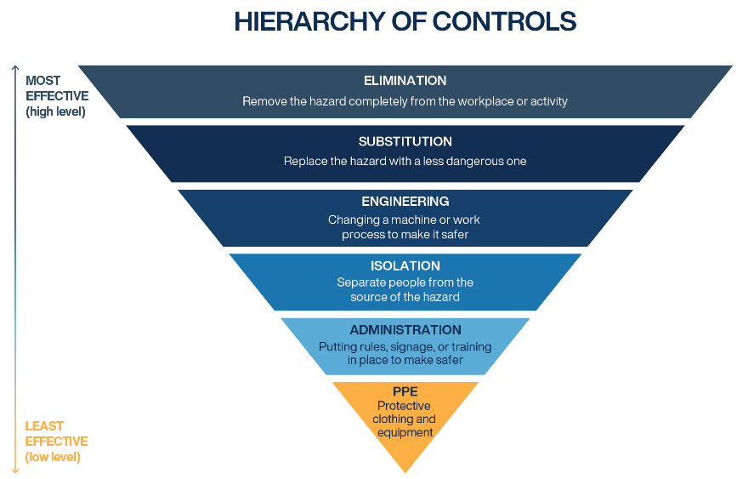

Activity description  (Sequential steps) | Hazard/risk factor | Inherent  risk score | Control description  (Current and proposed) | Control type | Residual risk score

STEP 2 – Outline emergency response
Are there arrangements for: | Yes/No | Outline arrangements
Emergency evacuation
Emergency communication
First aid

Have any hazardous substances been identified? |  | If yes, specify
Safe handling procedures in place?
Emergency response plan available in vehicle? |  | If yes, specify location

Emergency contacts
Activity coordinator contact(s)
First aid officer
Nearest accessible reliable phone
Nearest hospital (if task is location specific)
Ambulance/police/fire

STEP 3 – Implementation and consultation process
Determine the person responsible for reviewing and implementing the risk assessment including the identified controls.
Obtain the authorisation of the management representative.
Ensure the HSR (if applicable) has been consulted. Ensure the employees undertaking the activity have been consulted.
Record below the names of the persons consulted.
Ensure risk has been added to the risk register.
Management representative |  |  | HSR/employee representative (if applicable)
Employee(s) |  |  | Employee(s)
Employee(s) |  |  | Employee(s)
Person responsible for implementation or escalation

