Purpose
This procedure describes how to . . . or
This procedure describes the process required to . . .
[Describe the purpose of the procedure:
The purpose should briefly explain the task, the specific equipment involved, the operating conditions and the location.]

Note: | This is an example of a note format.  Copy the row and paste it elsewhere in your document.

WARNING: This is an example of a warning or danger format.
Copy the row and paste it elsewhere in your document.

Procedure use

When this procedure is to be used
This procedure covers . . . or
This procedure applies to . . .
[Describe the extent and boundaries of the task:
Describe ‘When this procedure is to be used’ should explain the extent and boundaries of the task. It should clearly explain when and to whom the procedure applies and when and how often it’s to be used.]

When this procedure is NOT to be used
This procedure does NOT cover . . . or
This procedure must NOT be done if . . .
[Describe the limitations and boundaries of the task:
Describe ‘When this procedure is NOT to be used’ should explain the limitations and boundaries of the task. It should clearly explain when and to whom the procedure DOESN’T apply or when the procedure must NOT be used or done.]

Competency and training requirements
The person carrying out the procedure must have completed the. . .
The person carrying out the procedure must be qualified or licensed to carry out the . . .
[Describe the level of competency and training requirements:
Describe the level of competency and training required to complete, or do the task. It should be very clear that a person must be qualified or have completed a specific training course or hold a certain certificate of competency before they start the task.]

What you require for the task

Personal protective equipment (PPE)
You will need the following personal protective equipment (PPE) to do this task:
- [Insert or record NONE]
- [Include: Identify the required PPE the person will need. Consider also using images to illustrate the requirements.]

Tools, equipment, parts and supplies
You will need the following tools, parts, supplies and equipment to do this task:
- [Insert or record NONE]
- [Include: Identify the required tools, equipment, parts and supplies the person will need. You should include information relating to quantities, sizes, certification and identification details. Be specific and include images to assist with identification.]

Related and required documents
You will need the following documents to prepare for, or do this task:
- [Insert or record NONE]
- [Include: Identify the documents the person will need. For example include: Checklists, permits, site access rules, maps, diagrams or procedures.]

Before you start the task
Before you start this task, ensure the following steps listed in the table below have been actioned.
[Include: Identify the pre-start requirements that need to be met before the task is started. It’s imperative that you highlight any pre-start conditions that MUST be met.
Consider using the WARNING format if you need to remind the person of any danger prior to starting the task.]
Step | Action
1. | [Example:  - READ required documents  - COMPLETE the pre-start checklist  - EXAMINE the work area or work site for hazards  - OBTAIN approval from the Site Manager.]

The task steps
The task steps are as follows:
[‘The task steps’ section outlines the actual steps that need to be followed to complete the task. The complexity of the task will dictate how you document the steps in your procedure.
A basic procedure may be as simple as a list of numbered steps, starting from 1.
A more complex procedure may also be a list of steps with sub sections providing more details to explain a specific action or activity.
You may also consider using a flowchart to show the person the step-by-step process to complete the procedure.
Regardless of the type of procedure you develop, each step should:
- identify the role responsible
- be a single action or activity
- start with a verb (e.g. IDENTIFY, LIFT, CHECK, TURN, WAIT)
- describe the result or outcome expected to verify the action or activity has been completed.]
Step | Role | Action
1. |  | [Numbers should be used to identify and separate each step and provide information to assist the person performing the action or activity.]
2. |  | [Decision based steps can be structured in the following manner:  Ask a question and if the response is:  - Yes...Then do this…  - No…Then do this…]
3. |  | [A more complex step may be broken down into sub-sections with more details explaining a specific action or activity.]
 |  | a | [Lower-case letters should be used to identify sub-sections.]
 |  | b | [Lower-case letters should be used to identify sub-sections.]

Flowchart (optional)
The flowchart below shows the step by step process to complete the procedure.
[The ‘Flowchart’ section provides a simplified step-by-step process diagram showing a series of actions or activities to be taken to complete the procedure. Detailed instructions on the steps identified in the flowchart can be provided in the ‘The task steps’ section.]
Flowchart shapes and examples
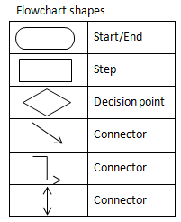  To use the shapes in Microsoft Word, click on Insert > Shapes. | 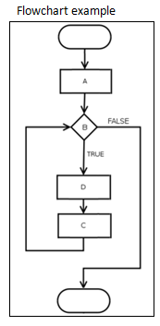 | 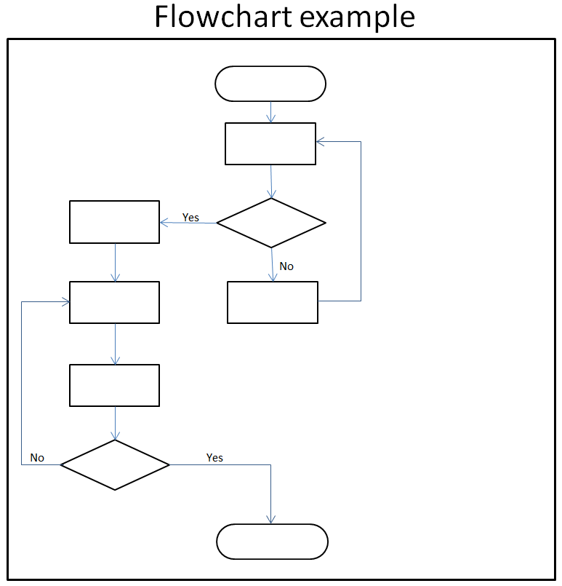

Reference documents
The following documents have been referenced in the procedure:
[The ‘Reference documents’ section should be used to list any documents that have been referenced elsewhere in the procedure. The purpose of this section is to guide the person to the source if they want further information.
If you use an electronic system to view your procedures, you could remove this section by providing a hyperlink to the document where it’s mentioned in the procedure.
To hyperlink reference documents in Microsoft Word, highlight the text (e.g. the document name) and click on Insert > Hyperlink.]
- < item > [Use italics when referencing legislation and other published documents]

Definitions
The following terms are specific to this procedure and require further explanation.
[The ‘Definitions’ section would only be used if you need to define the meaning of a word or term used in the procedure. Delete this section (including the definitions table) if not used.]
Term | Definition
[Safety exclusion zone] | - [an area where the anyone can stand and is NOT in danger of being hit by any mobile plant or freight during the loading and unloading process.  - NOT on the heavy vehicle’s trailer or tray.]

Revision history
[The ‘Revision history’ is worthwhile to keep a track of the changes that you have made to the procedure since it was introduced.
The ‘Last’ and ‘Next’ review dates are worth tracking to ensure the procedure is being reviewed from a continuous improvement perspective.
Delete this section (including the table) if not used.]

Rev | Date | Status | Author | Nature of change | Authorised by | Date
 | [Select] |  | [<initial> <surname>] |  |  | [Select]
 | [Select] |  |  |  |  | [Select]
Last review date |  | [Select]
Next review date |  | [Select]

