Purpose
This procedure describes how to safely load and unload a heavy vehicle by setting up a safety exclusion zone within a loading/unloading area.

Procedure use

When this procedure is to be used
This procedure covers the setup of a safety exclusion zone when loading and unloading a heavy vehicle where the site does not have a safe and established procedure already in place.
This procedure applies to all drivers (including subcontractors) loading and unloading a heavy vehicle at a customer site.

When this procedure is NOT to be used
This procedure does NOT cover loading and unloading a heavy vehicle where the site does already have a specific established safety exclusion zone procedure in place.
This procedure must NOT be used if the safety exclusion zone is placed on the trailer or tray of the heavy vehicle.

Competency and training requirements
The person carrying out the procedure must have been trained and issued with a company certificate of competency specifically covering the setup of a safety exclusion zone for loading/unloading of a heavy vehicle.
The person carrying out the procedure must have participated in the Heavy Vehicle Loading and Unloading Safety training course.

What you require for the task

Personal protective equipment (PPE)
You will need the following personal protective equipment (PPE) to do this task:
- High visibility vest
- Hard hat

Tools, equipment, parts and supplies
You will need the following tools, parts, supplies and equipment to do this task:
- Ground markers (Orange witches hats with reflective strip)

Related and required documents
You will need the following documents to prepare for, or do this task:
- Pre-start checklist

Before you start the task
Before you start this task, ensure the following steps listed in the table below are completed.
Step | Action
1. | READ this procedure
2. | COMPLETE the pre-start checklist
3. | CONTACT the site representative
4. | EXAMINE the work area or work site for hazards

The task steps
The Driver of the heavy vehicle performs the following key steps:
Step | Action
WARNING: AT ALL TIMES while the forklift / mobile plant operator (FMPO) is loading or unloading:
- the driver MUST be standing in the safety exclusion zone AND
- the driver and FMPO MUST have VISUAL CONTACT with each other while working in and around the heavy vehicle. IF NOT – STOP THE JOB (i.e. ‘Can’t see Can’t work’).
A ‘safety exclusion zone’ is:
- an area where the driver can stand and NOT be in danger of being hit by the FMPO or freight during the loading and unloading process.
- NOT on the heavy vehicle’s trailer or tray.
FMPO = Forklift / Mobile Plant Operator

1. | WHEN you arrive at the site:  - SPEAK with the site representative AND  - CONFIRM if a safety exclusion zone area is already in place at the site for loading/unloading.
 | a | IF a safety exclusion zone area IS in place for the site, THEN  - DISCUSS AND CONFIRM the correct site procedure with the site representative.  - OBTAIN and READ the written procedure for the safety exclusion zone, AND  - FOLLOW the site procedure as discussed and documented, AND  - Continue to Step 3
 | b | IF a safety exclusion zone area is NOT in place, THEN  - CONSIDER the type of freight being loaded or unloaded to IDENTIFY the required size and suitable location for the safety exclusion zone.  WARNING: The type of freight you are handling (e.g. long lengths of steel pipe) could slide and may require you to extend the size of the safety exclusion zone and distance from the heavy vehicle.  - CONFIRM the safety exclusion zone size and suitable location in relation to the required loading/unloading area.  - CONFIRM if you have exclusion zone ground markers or suitable items that can be used as ground markers.  Note: You may be able to create a temporary safety exclusion zone using suitable items that are available at the site.
2. | a | IF you do NOT have ground markers look for a suitable alternative to mark out the exclusion zone, THEN  - DISCUSS the safety issue with the site representative, AND  - AGREE to an area suitable for a safety exclusion zone and the safe work method per the warning at the start of the procedure.
 | b | IF you DO have exclusion zone ground markers, THEN  - USE your ground markers to MARK OFF your safety exclusion zone area.
3. | BEFORE loading or unloading:  - SPEAK with the FMPO, AND  - AGREE how the safety exclusion zone works  - CONFIRM the safe work method while loading or unloading  - ESTABLISH a ‘Can’t see Can’t work’ understanding with the FMPO.
4. | PREPARE the vehicle for loading or unloading and advise the FMPO that it is clear to start.
5. | STAND or WAIT in the safety exclusion zone and await instructions from the FMPO.
6. | FMPO SHOULD CONFIRM that loading or unloading has been completed.
7. | PREPARE vehicle to depart site and PACK UP exclusion zone ground markers.

Flowchart
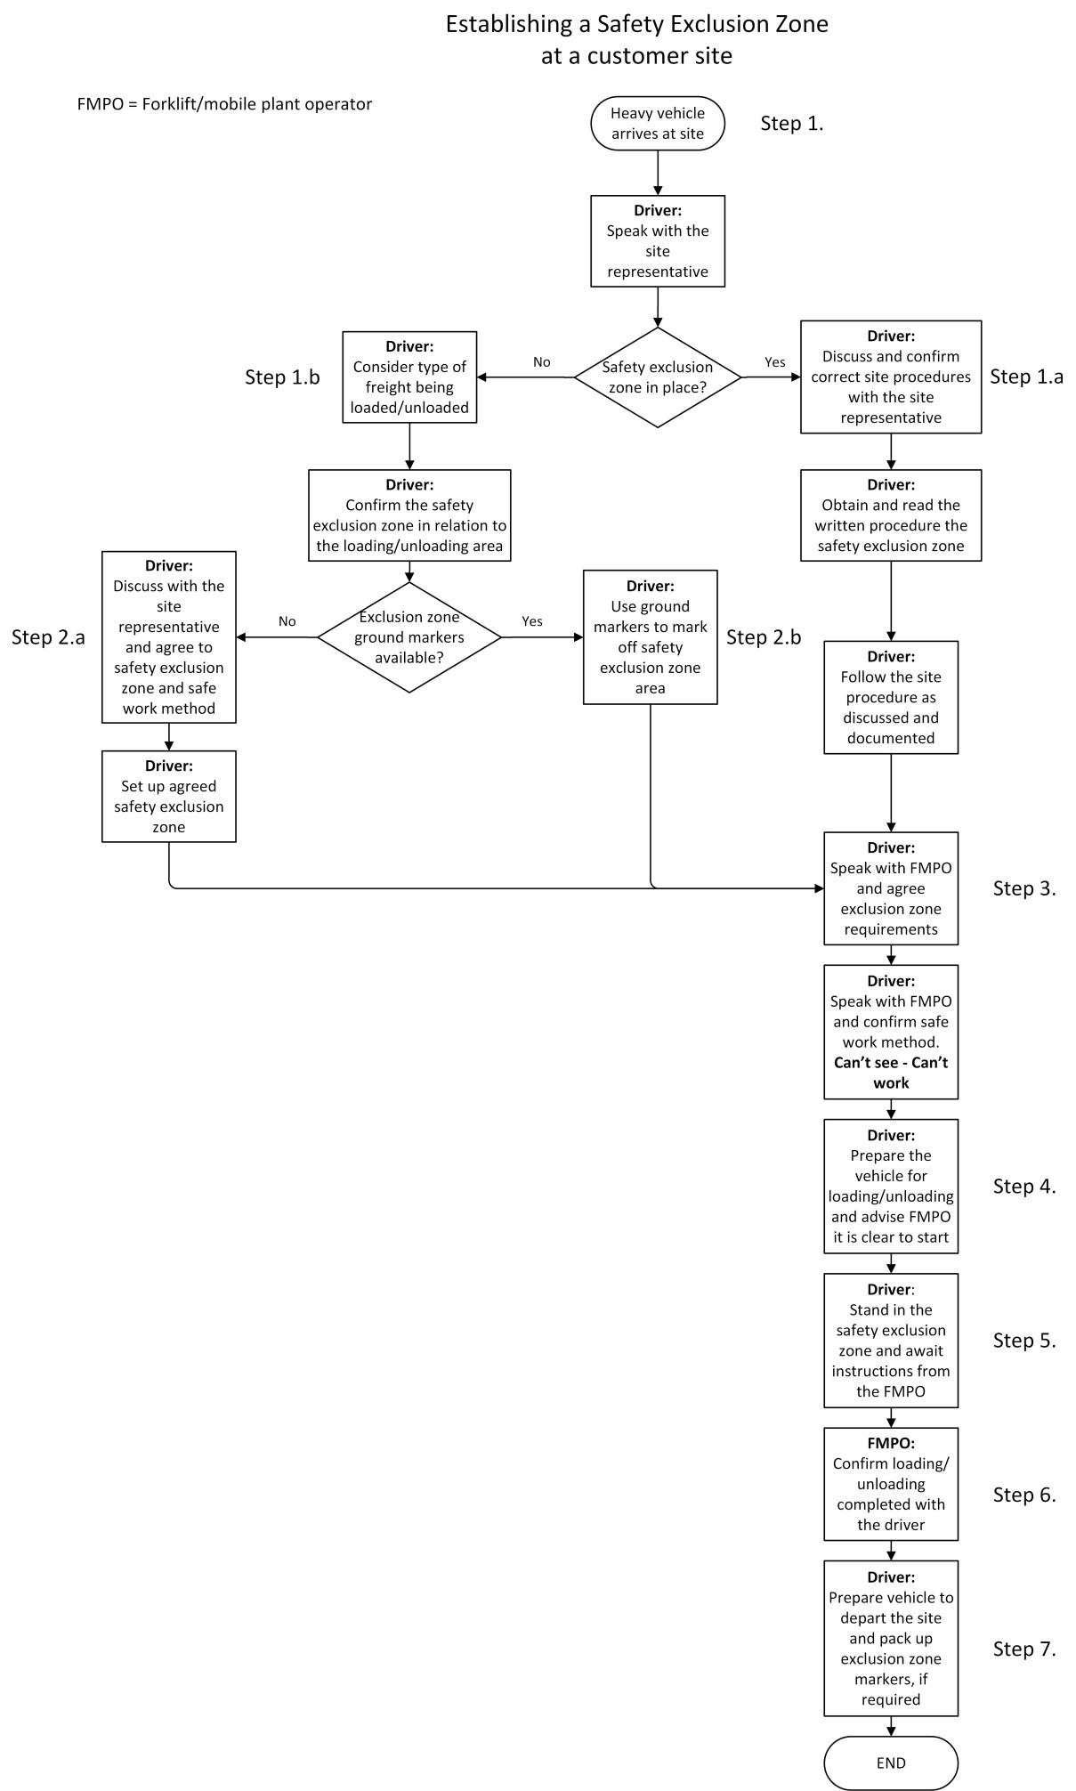

Reference documents
No other documents have been referenced in this procedure.
Supporting document:
Load Restraint Guide 2018, National Transport Commission Australia

Definitions
The following terms are specific to this procedure and require further explanation.
Term | Definition
FMPO | - an abbreviation for Forklift / Mobile plant operator
Ground marker | - high visibility safety cones, or  - suitable items that can be used as ground markers
Mobile plant | any plant that is provided with some form of self-propulsion that is ordinarily under the direct control of an operator, and includes:  - earthmoving machinery (e.g. rollers, graders, scrapers, bobcats)  - excavators  - cranes  - hoists  - elevating work platforms  - concrete placement booms  - reach stackers and forklifts.
Safety exclusion zone | - an area where the driver can stand and NOT be in danger of being hit by any mobile plant or freight during the loading and unloading process.  - NOT on the heavy vehicle’s trailer or tray.

Revision history
Rev | Date | Status | Author | Nature of change | Authorised by | Date
1 | 20/12/2020 | Original | Mr Safety | Procedure developed based on Risk assessment RA-037 | S. Safety | 22/12/2020
2 | 20/02/2021 | Revised | Mr Safety | Procedure updated to add a flowchart | S. Safety | 22/02/2021
Last review date |  | 20/02/2021
Next review date |  | 19/12/2021

