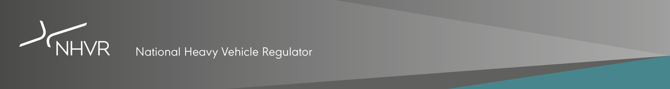
National Heavy Vehicle Inspection Manual
Feedback Form
This form should be used to raise technical issues with the National Heavy Vehicle Inspection Manual (NHVIM). To enable the NHVR to keep pace with changing vehicle design, technology and regulation, the NHVIM is web published as a live document. The manual will be regularly revised by the NHVR.
Completed feedback forms should be submitted by email to vehiclestandards@nhvr.gov.au.
The NHVR will review each submission and determine if it is to be added to the NHVIM maintenance log and the timing of any updates. The NHVR will advise all proponents of the initial assessment outcome within 28 days of receiving a complete submission.

Your details
Summary of issue: | A short description of the issue
What section of the manual does this issue relate to:  (may tick one or more boxes) | ☐ Section 1 – Vehicle identification  ☐ Section 2 – Brakes  ☐ Section 3 – Couplings  ☐ Section 4 – Steering and suspension  ☐ Section 5 – Wheels, tyres and hubs  ☐ Section 6 – Structure and body condition  ☐ Section 7 – Seats and seatbelts  ☐ Section 8 – Lights and reflectors  ☐ Section 9 – Mirrors and Indirect Vision Devices  ☐ Section 10 – Windscreens and windows  ☐ Section 11 – Engine, driveline and exhaust  ☐ Section 12 – LPG, NG, Hydrogen and Electric vehicles  ☐ Section 13 – Buses  ☐ Section 14 – Trailers  ☐ Section 15 – Motorhomes, campervans and caravans  ☐ Section 16 – Vehicle dimensions  ☐ Other: (Specify)
Which reason for rejection does this issue relate to (provide separate details for each issue identified in each section):
For example, 1.1 a
Proponent (organisation and primary contact person/details): | Provide responsible officer/s:  Organisation, name, title, contact details
Date submitted to NHVR:

What is the issue? | Identify and define the problem/why is it a problem i.e. will result in unsafe component/ system not being identified during an inspection?  What evidence is there regarding the scale of the problem?  Who is affected?
Does this issue relate to regulation?  Does this issue relate to a provision of the Heavy Vehicle (Vehicle Standards) National Regulation or the Australian Design Rules? | What section or clause of the Regulation or ADR does this issue relate to?
Proposed solution: | What is the proposed solution to address the issue?  If a new reason for rejection or amendment of an existing reason for rejection is proposed, please include suggested wording for consideration. Include diagrams, schematics, photos or supporting documentation that may be of assistance in highlighting the issue.
Urgency:  When must the issue be resolved by?  (please tick one box only) | ☐ Urgent (immediate update)  ☐ Not urgent (next section update)  ☐ Routine (next NHVIM review)  Reason/s:

